**How to use Google Cloud Platform**

**Contents:**

1. How to use GCP.
2. How to enable an API (e.g. Speech to Text)
3. How to add multiple user to a project
4. **How to use GCP**

* To use google cloud platform one need to have a google account.
* Open the link <https://cloud.google.com/> and click on “Get started for free”.

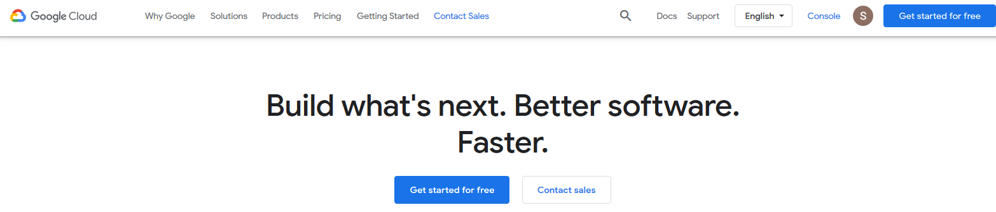

* Follow the steps as shown the screen about the personal information.
* GCP also requires a credit card information for billing purpose and initially auto-payment is off and can be enabled from the main console.

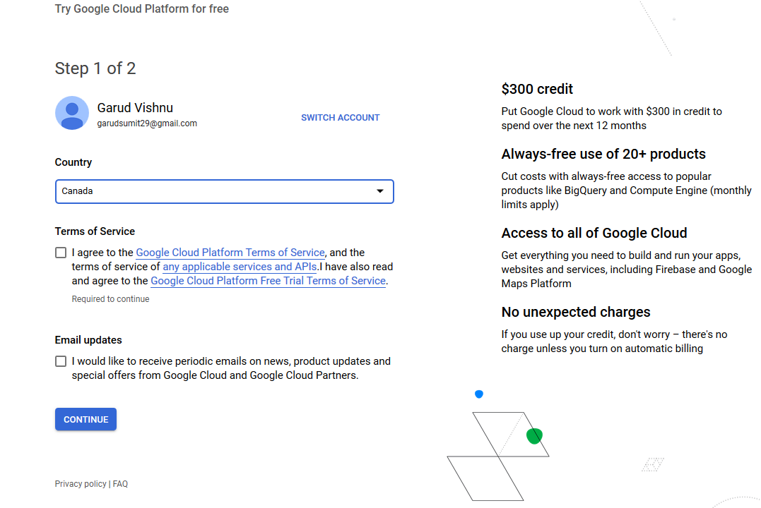

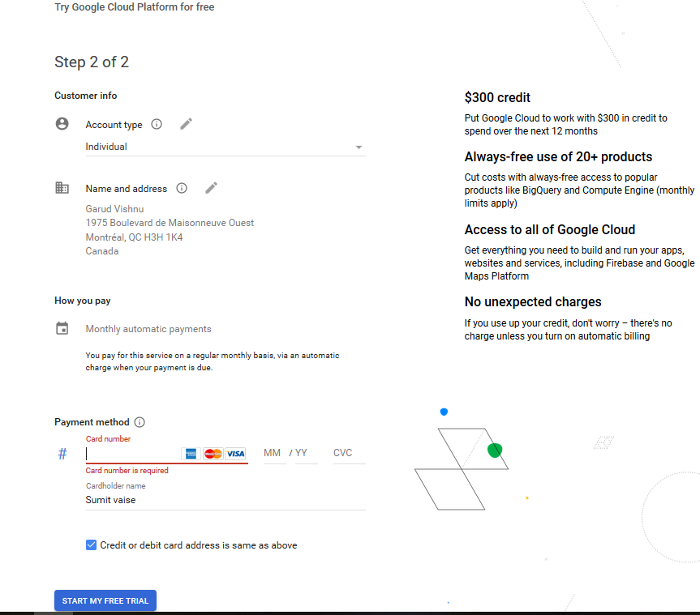

* Click on the “Start my free trial” to start using GCP for free.
* This will lead to the main console page of GCP. To navigate anytime to main console page from anywhere in the GCP documentation click on the “console” on the right top corner.

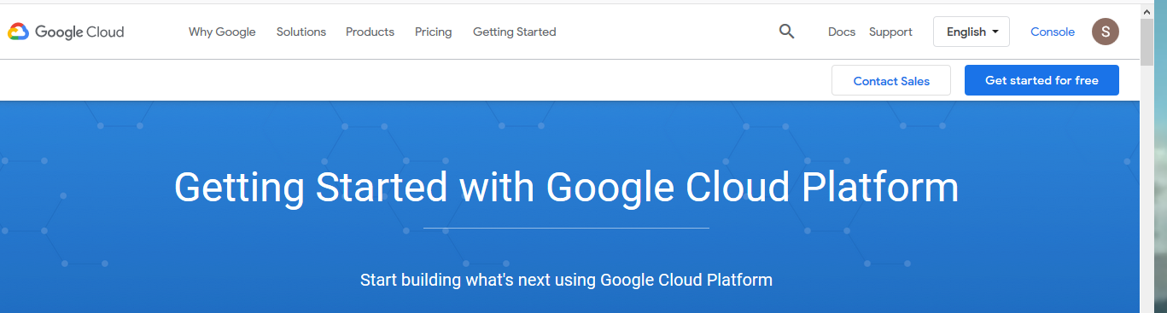

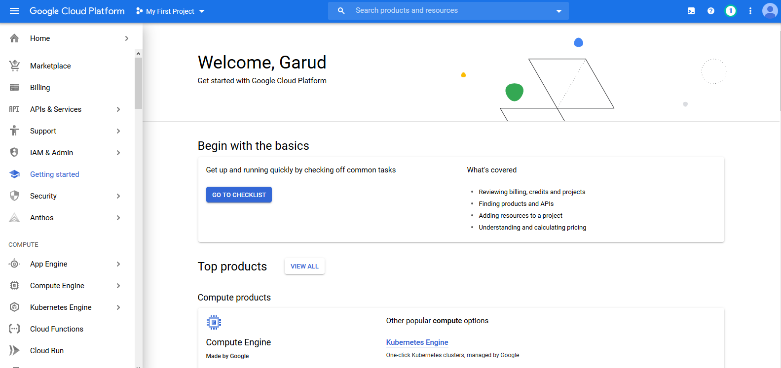

Fig. Console or Dashboard of your GCP account.

1. **How to enable an API (e.g. Speech to Text)**

* From the GCP dashboard page click on the “APIs & Services” option. This will lead you to the below page.

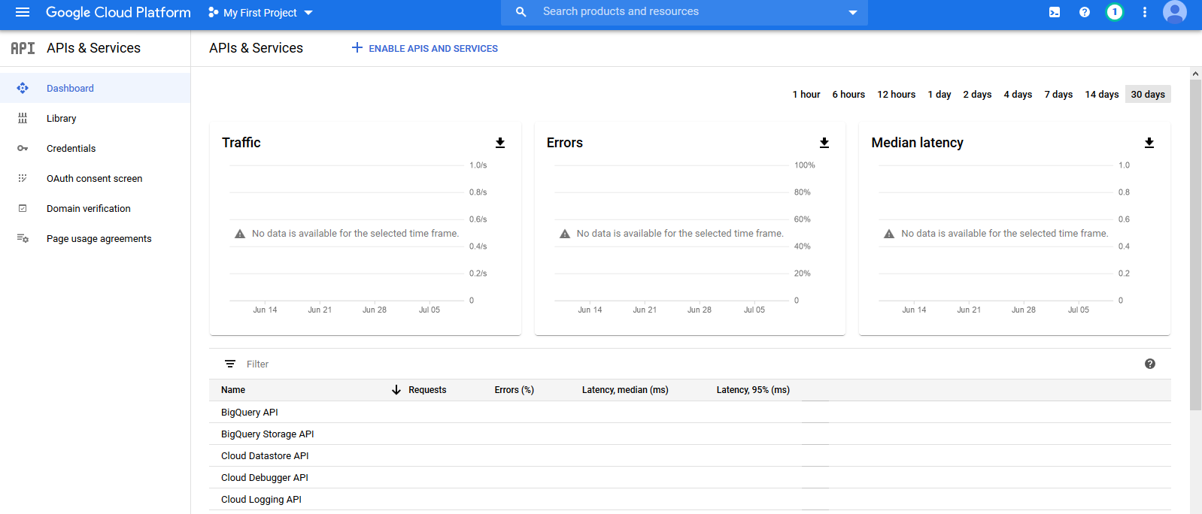

* Then click on “Enable APIs and Services” available at the top centre of the page to find the desired API.

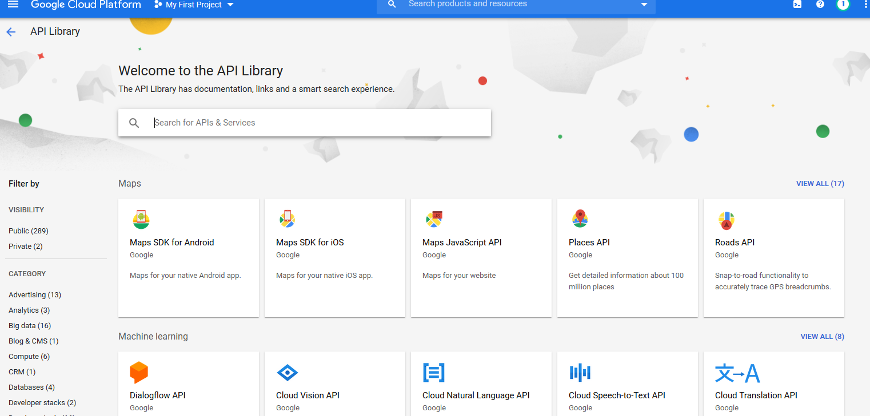

Fig. APIs page after clicking on “Enable APIs and Services”

* On the above page search for your desired API for e.g. “Cloud Speech-to-Text” and enable it.

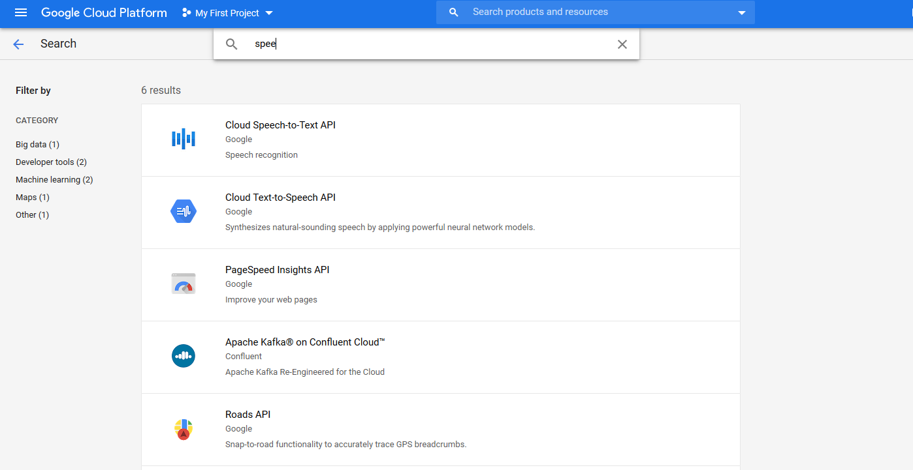

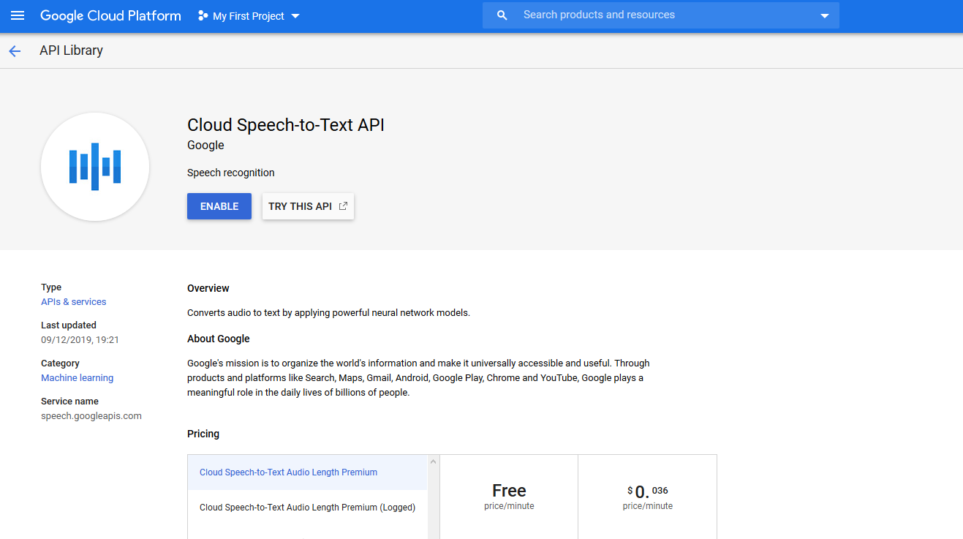

* All API’s page contains information about their usage and pricing.

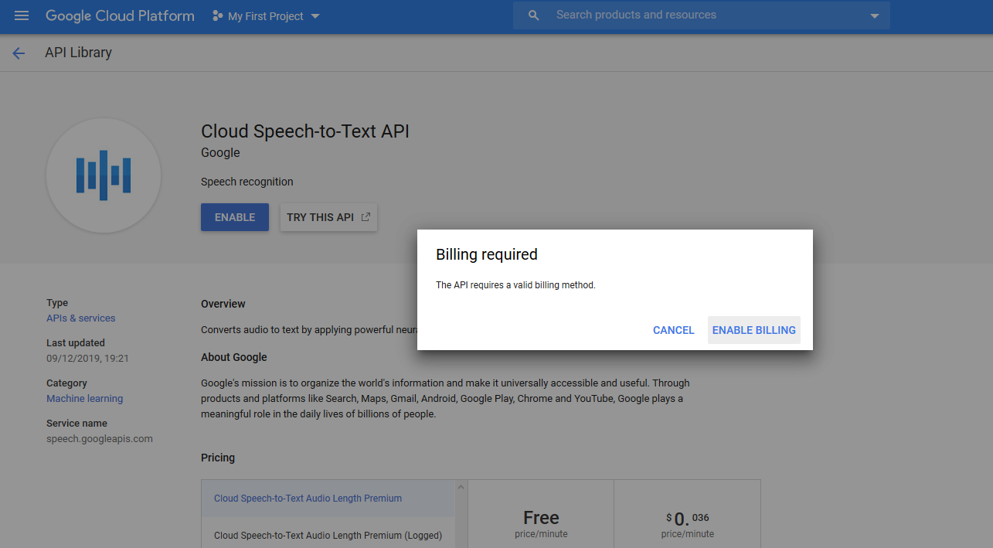

* Once enabled can be found under “Go to APIs overview” from **Dashboard API** column.

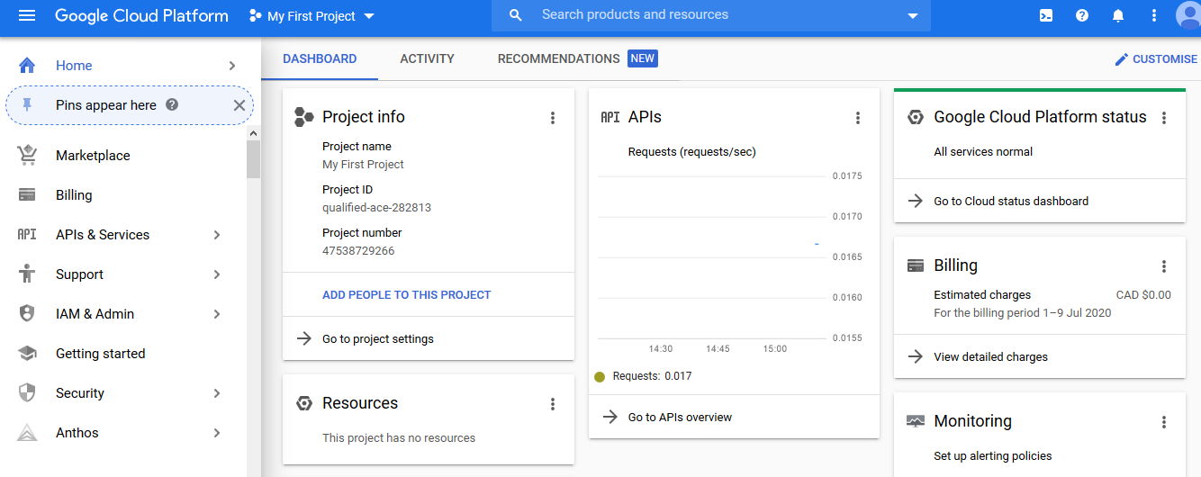

* Click on the “Go to APIs overview” to look for the enable API. On this page scroll down to find the enabled API.

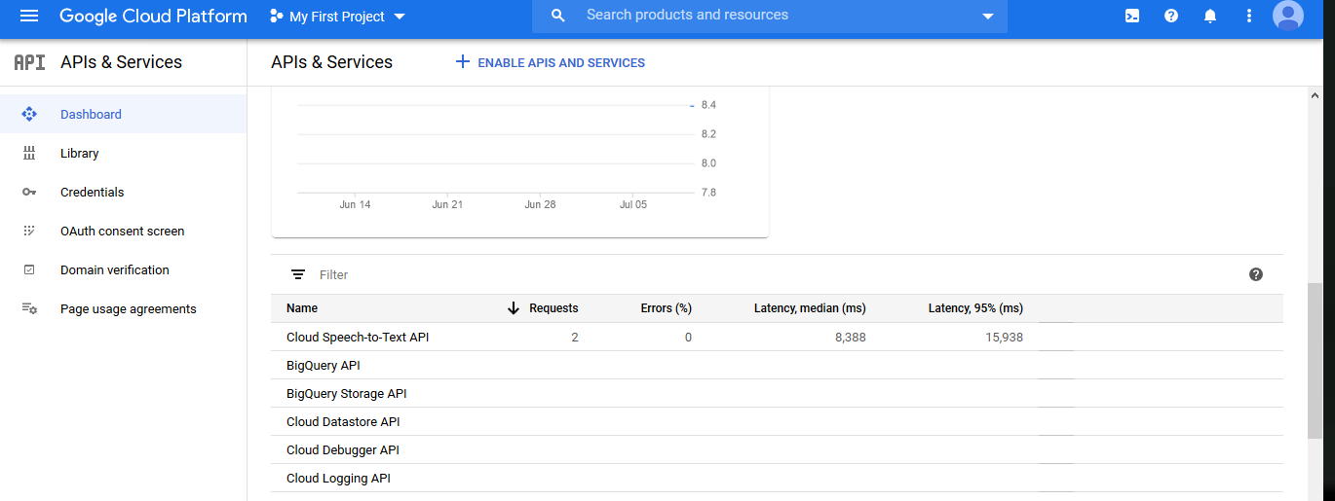

* API can be disabled by clicking on the API and then choosing to disable it.

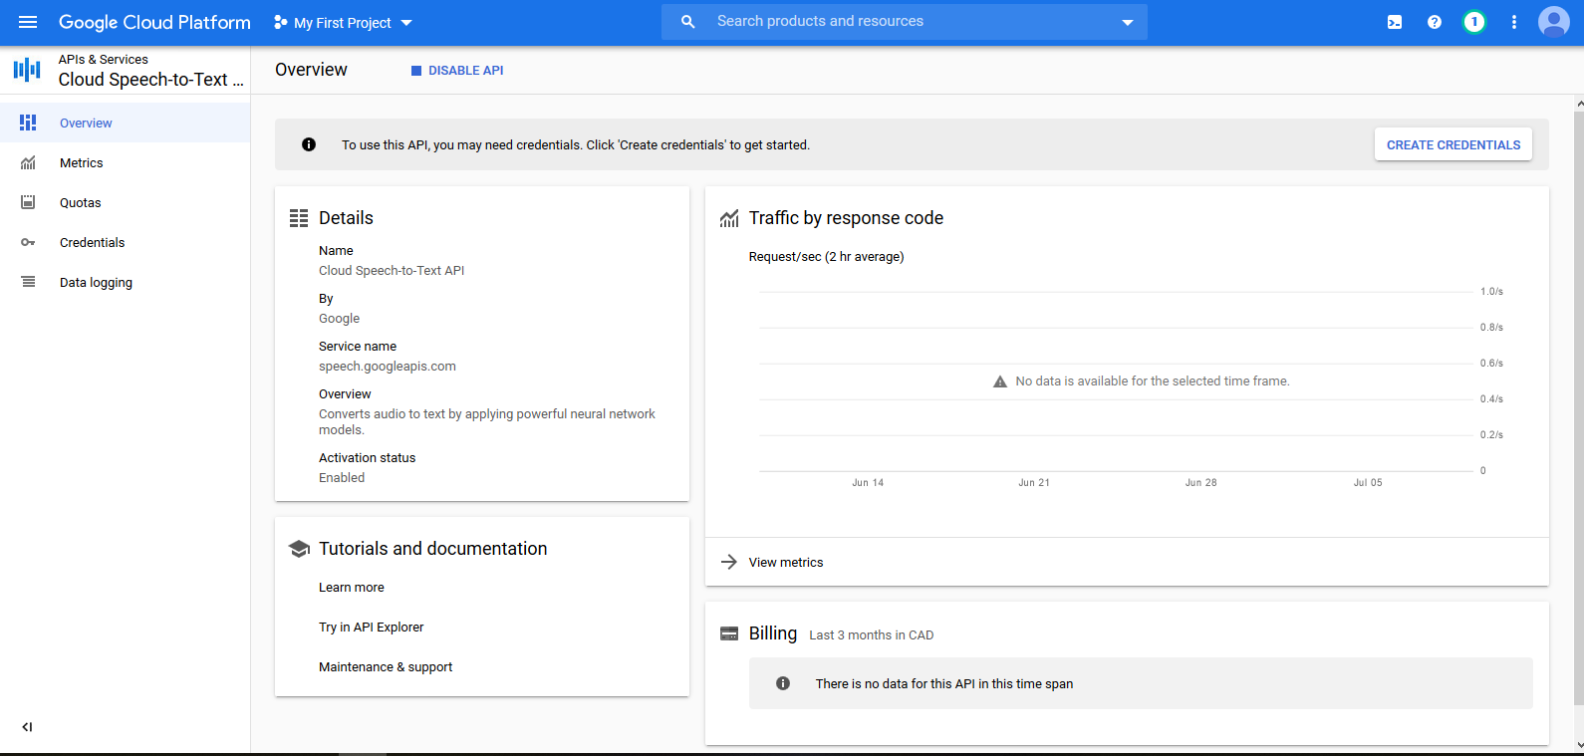

* To use the desired API we need to generate credential. Follow the instructions and options selection as shown in the images below:

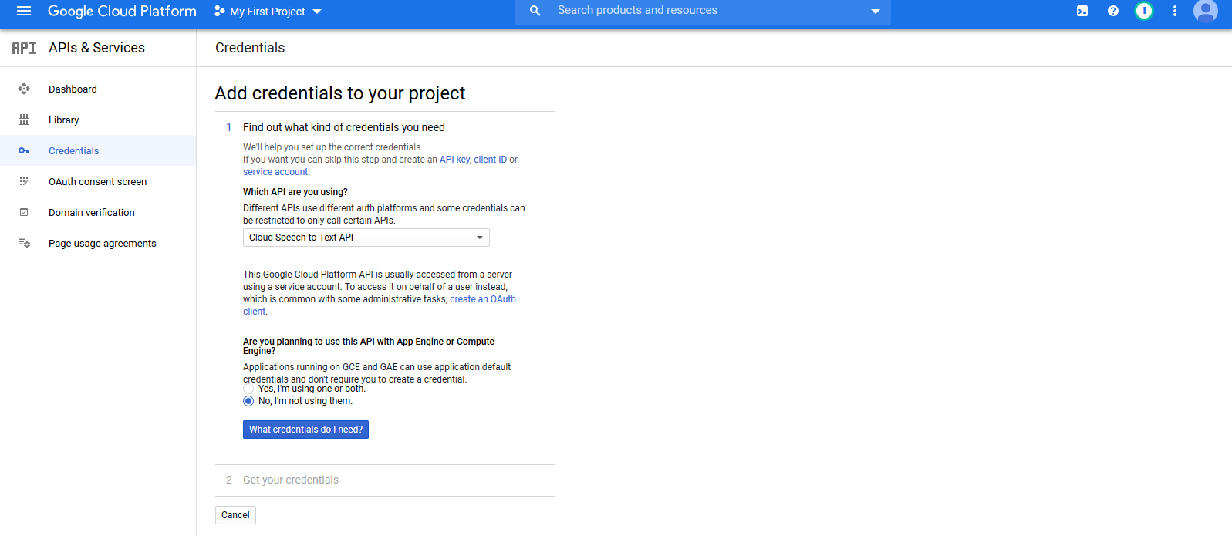

* When you click on the “What credential do I need?”. This option allows you define the role you want to be for the project. All the APIs are defined under a project with certain rules and permission. Since its my account and I want to use it on my project I would like to be the owner of the project so that I can enable or disable it or add any other APIs as needed. If I am not the owner of the project one cannot modify the properties or the settings of the project like billing, enabling or disabling of an API.

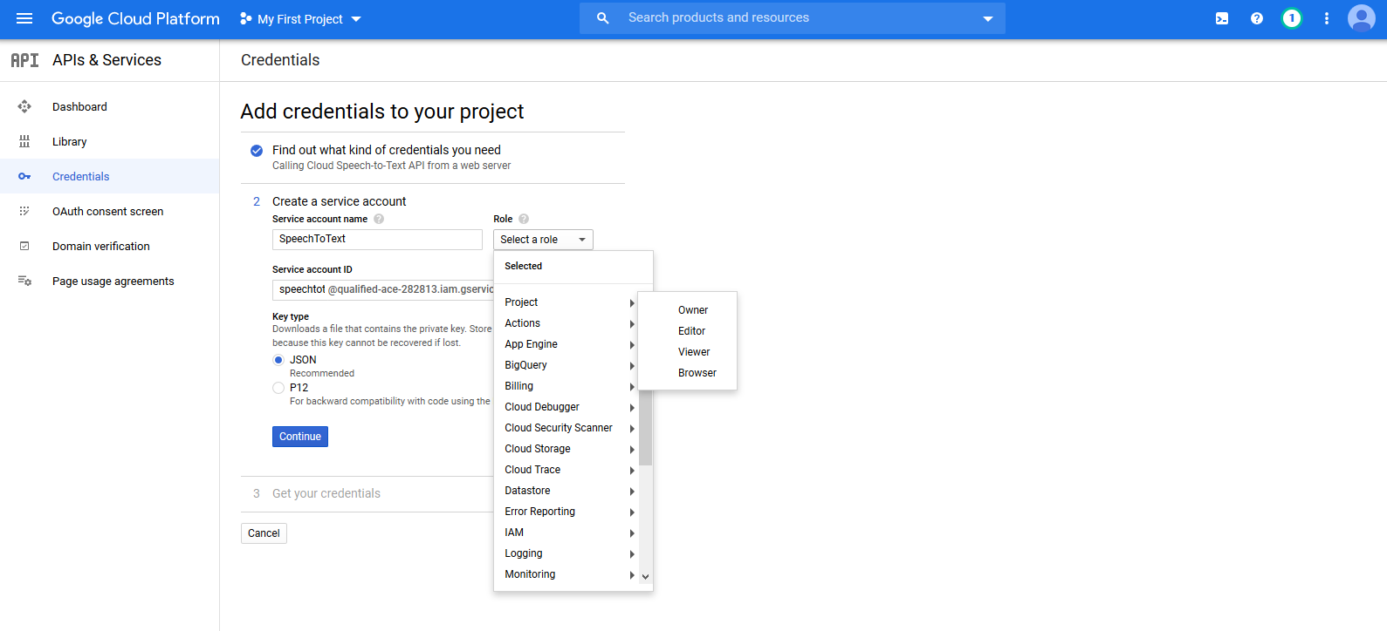

* Here we would like to use a “Key” which acts a config file which allows any application to use Google cloud services.

1. **How to add multiple user to a project**

This section helps in adding multiple user to a project.

* One can create multiple project with API’s and add user to it.
* This can provide the information about the usage of cloud services for a particular user and can charge as per the usage.
* Better way is to create a different project as above and add user as an IAM as shown in below images.
* Click on three horizontal lines from the top left corner and under “Products” select “IAM & Admin” and then select “IAM”.
* Under “IAM” page click on “Add” from the centre top position to add user.
* Follow the steps as shown in the screen.

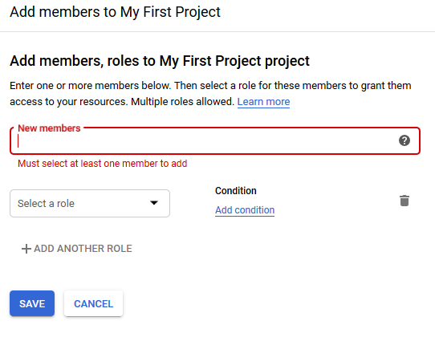

* To add a member, a gmail account is required or a user without gmail account user needed to be added to the Google group and that Google group email id can be used for adding the user.
* If any extra condition (day, hours etc.) you would like to impose on the new user can be imposed using condition option shown the same page after “Select role”.

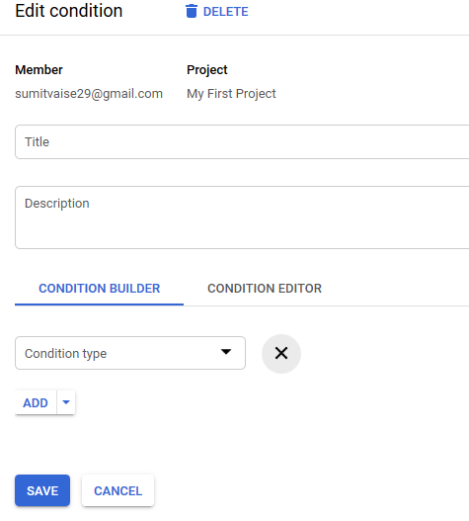

* Once user information is saved, a confirmation mail will be sent to the user to confirm once done can be seen under “IAM” page.

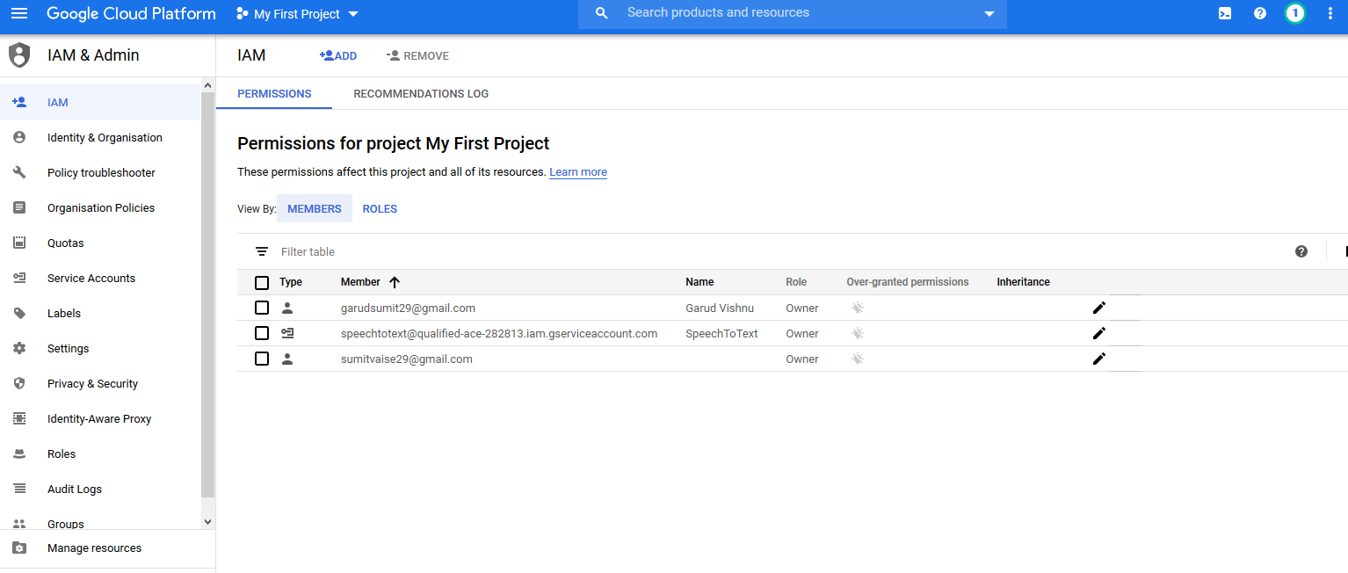

**Fig.** [**garudsumit29@gmail.com**](mailto:garudsumit29@gmail.com) **is GCP account and** [**sumitvaise29@gmail.com**](mailto:sumitvaise29@gmail.com) **is the new user added to the project to use S2T API.**

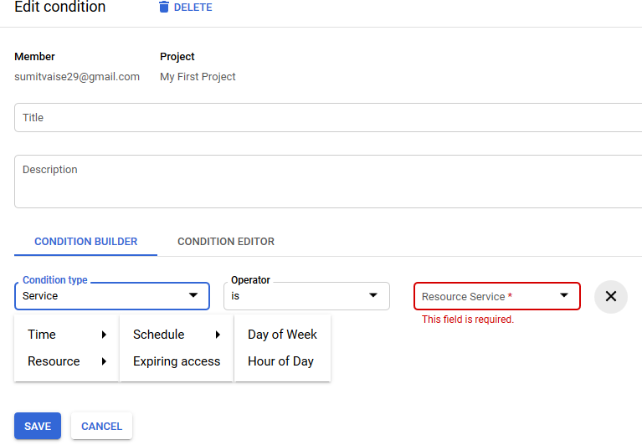

**How to add user without a gmail account:**

[**https://cloud.google.com/iam/docs/faq**](https://cloud.google.com/iam/docs/faq)

